PROJECT DATABASE

GROUP MEMBERS:
Muhammad Hammad Shakeel
Sikandar Khaleel
Aurshia Mudassar

MILESTONE | DATE | VERSION | REMARKS
ERD + SCHEMA | 24 / 4 / 2026 | V1.0 | Do Improvement in schema
Improvement in schema | 29 / 4 / 2026 | V1.1 | M2
M2: 3NF | 5 / 5 / 2026 | V2.0 | M3
M3: CSV’s | 12 / 5 / 2026 | V3.0 | M4
M4: DDL | 15 / 5 / 2026 | V3.0 | M5
M5: DML | 17 / 5 / 2026 | V4.0

SCHEMA: 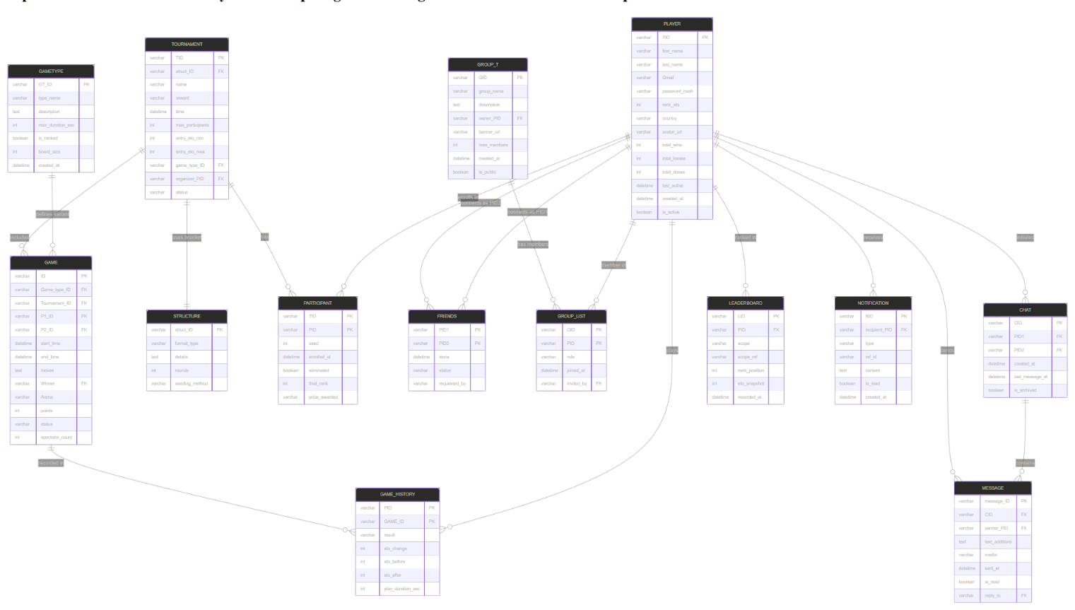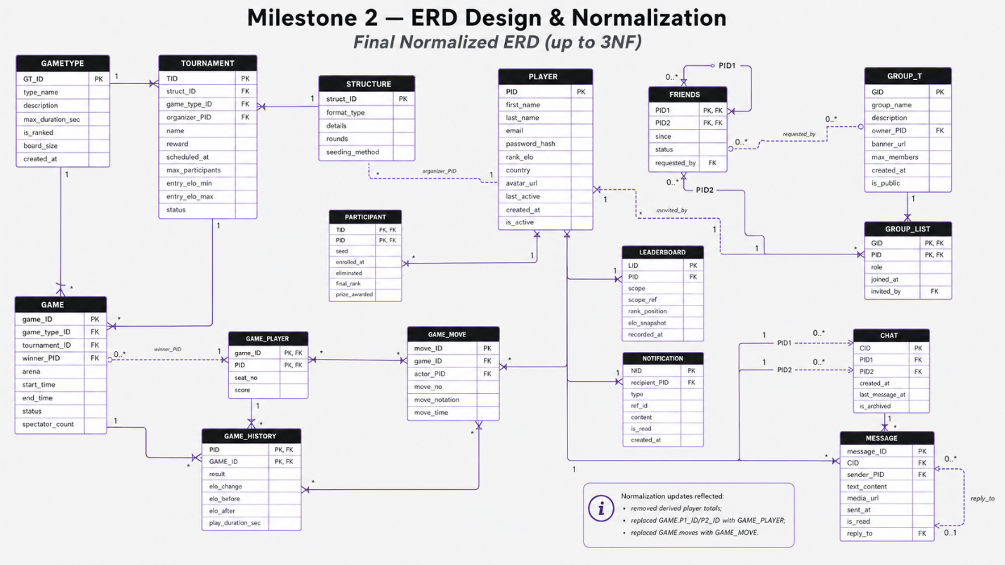

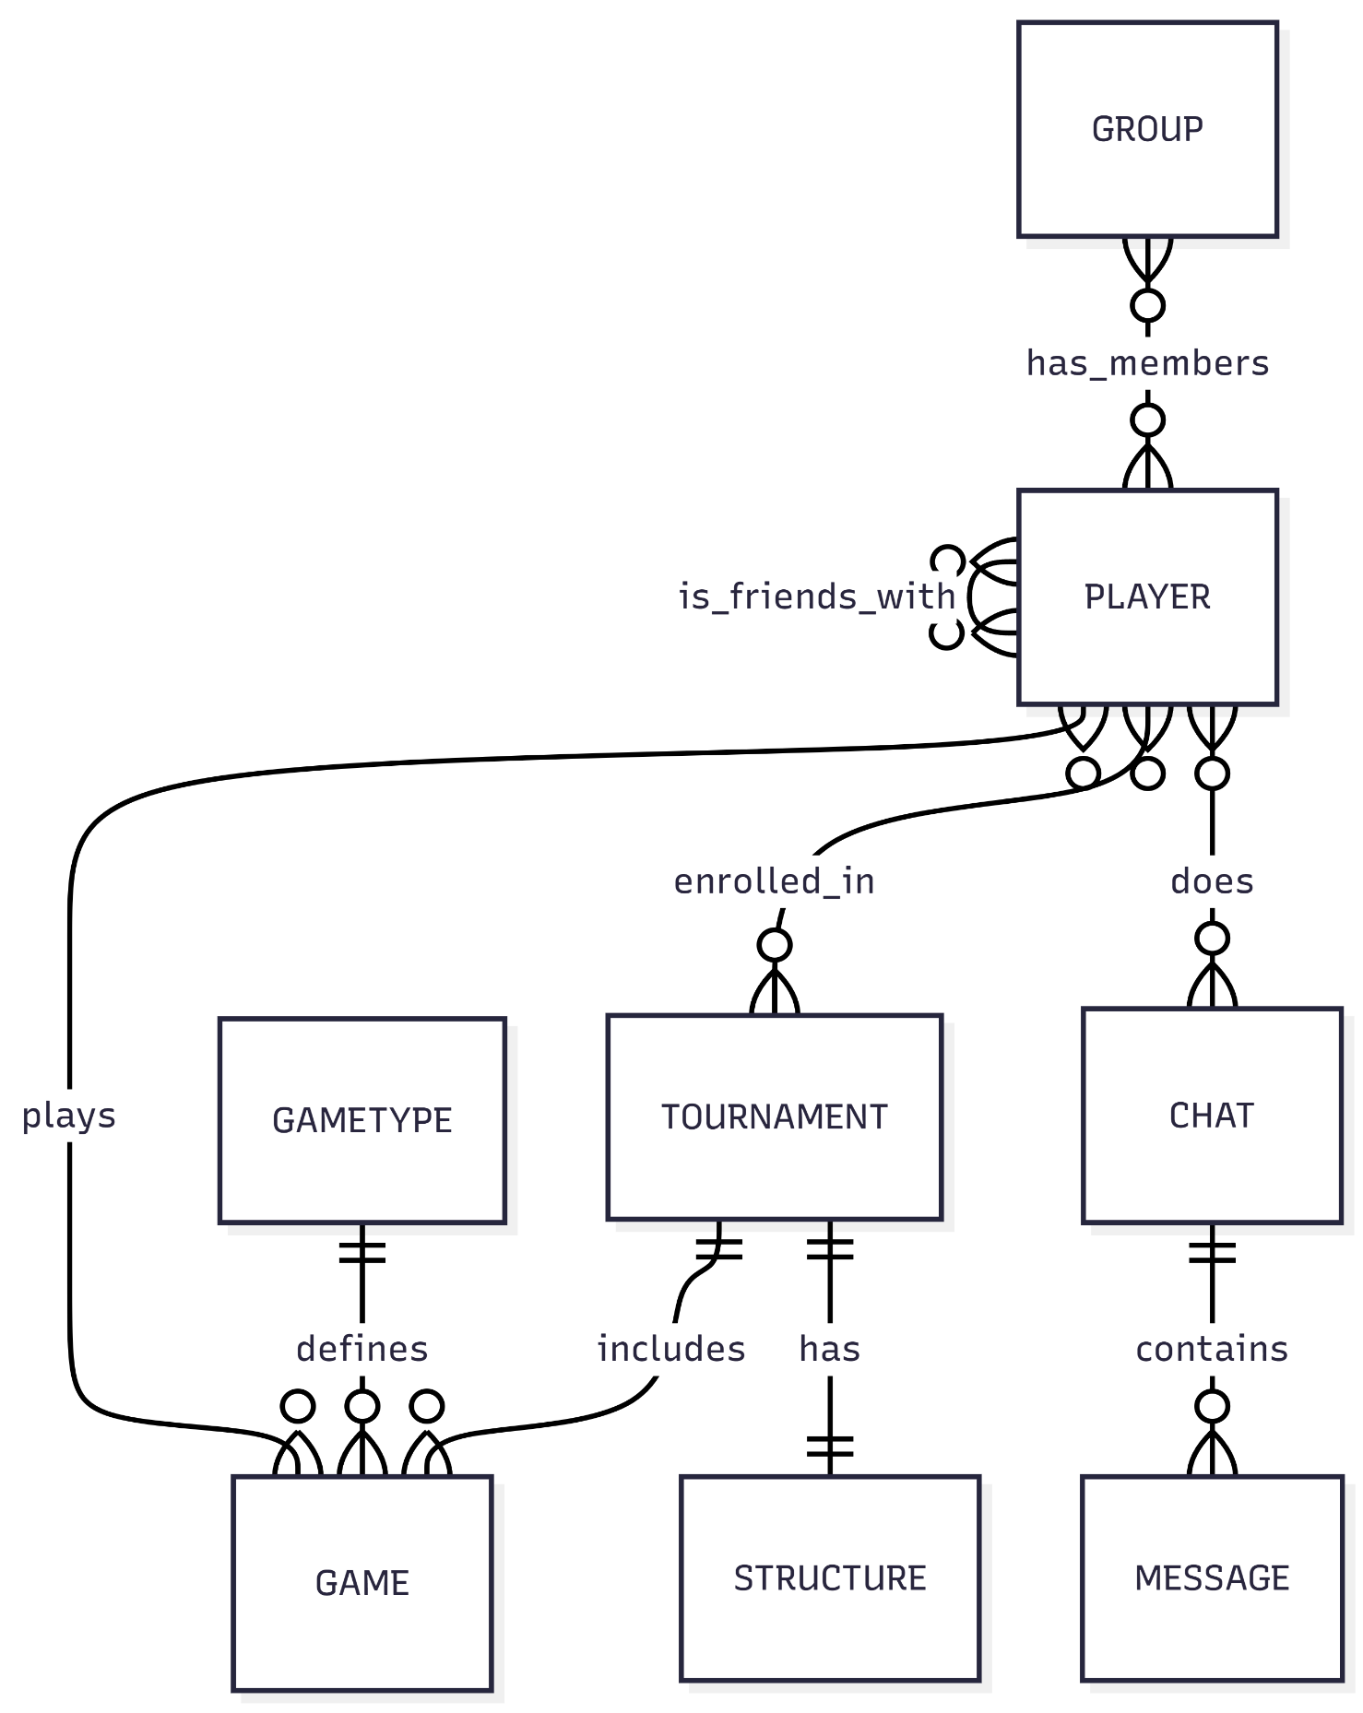
ERD:

The database supports a Super Tic-Tac-Toe multiplayer platform with ranked games, tournaments, friends, groups, and chat features.
GAMETYPE stores available game variants such as Classic, Blitz, Super, and Ultimate.
PLAYER stores registered users, including name, email, ELO rank, country, avatar, and account status.
GAME records each match, including game type, players, start/end time, moves, winner, points, arena, and status.
GAME_HISTORY links players to games and records each player’s result and ELO change.
TOURNAMENT stores competitive events, rewards, start time, participant limits, and tournament status.
STRUCTURE defines the tournament format, such as single-elimination, round-robin, Swiss, or double-elimination.
PARTICIPANT links players to tournaments and tracks seed, enrollment time, and elimination status.
FRIENDS manages friendships between players using a self-referencing relationship.
GROUP stores player-created communities, including owner, description, visibility, and creation time.
GROUP_LIST links players to groups and records their role and join date.
CHAT represents direct message threads between two players.
MESSAGE stores individual chat messages, including sender, text, media, timestamp, and read status.
The main relationships are: players play games, join tournaments, form friendships, belong to groups, and chat through messages. Junction tables are used for many-to-many relationships. Foreign keys maintain referential integrity, and important rules include preventing duplicate chats, self-friendships, duplicate memberships, and ensuring ELO updates happen safely after ranked games.

